Noakhali Science and Technology University

Department of Information and Communication Engineering

**DIGITAL IMAGE**

**PROCESSING**

**LAB MANUAL 1**

Introduction to MATLAB

(MATLAB Basics)

Prepared By: Md. Sabbir Ejaz

Lecturer, Dept. of ICE

Noakhali Science and Technology University

Department of Information and Communication Engineering

**Lab Objectives:**

This objective of this lab is to understand

1. What is MATLAB?
2. All MATLAB windows in detail. [Command window, Graphics window, Editor window, Workspace, Variable panel, Command history, Current directory]
3. Basic MATLAB command with example.
4. Working with variables, vectors, and Matrix
5. Working with library functions.
6. Getting started with MATLAB plotting tools.

**What is MATLAB:**

MATLAB = Matrix Laboratory. MATLAB is a high-level language and interactive environment that enables you to perform computationally intensive tasks faster than with traditional programming languages such as C, C++ and Fortran. [[www.mathworks.com](http://www.mathworks.com)]. It is an interactive, interpreted language that is designed for fast numerical matrix calculations.

**Software:**

MATLAB (any version higher than 2014a)

Figure 1

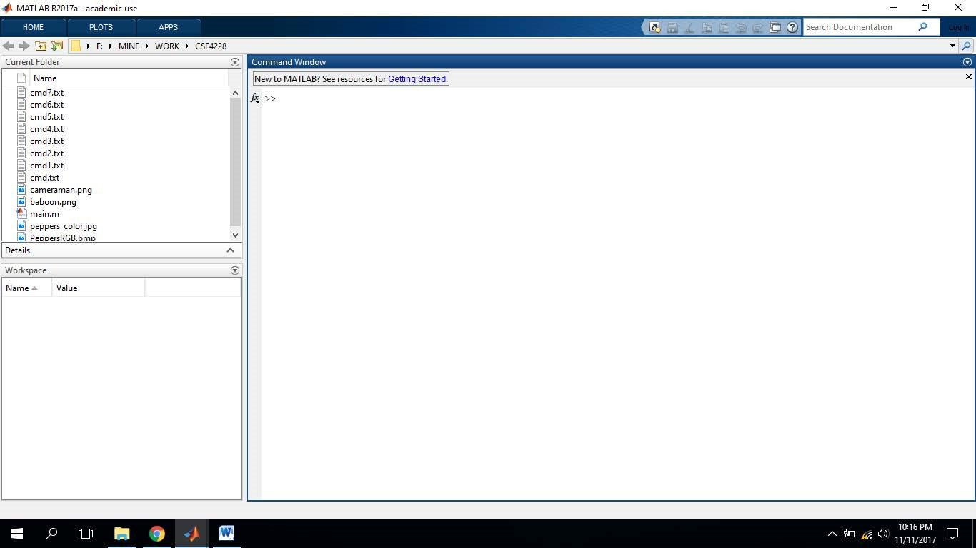

The desktop includes these panels (Figure 1):

* Current Folder — Access your files.
* Command Window — Enter commands at the command line, indicated by the prompt (>>).
* Workspace — Explore data that you create or import from files.

**Variables and the Workspace:**

Let’s start with variable.

a = 2

After entering, the immediate next line will display the variable with the assigned value.

a=

2

And you can see that, the variable is appeared in the workplace like Figure 2(a). If you double click on that variable icon, a panel named ‘Variables’ will popup like Figure 2(b).

MATLAB stores everything as matrix. You can note the indication of 1 x 1 double in the variable panel. It mean a is a 1 by 1 matrix (eventually a matrix with only one element), which is double type. By default any numerical data is double type. There are other data types as well such as uint8 (unsigned integer 8 bit), char (character), logical (boolean).

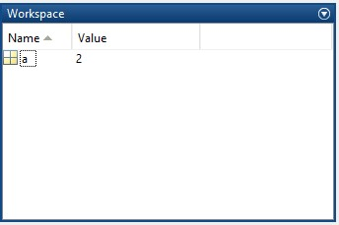

(a)

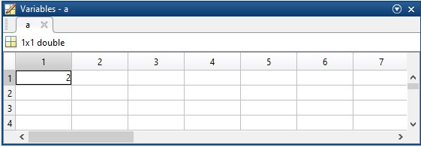

### (b) Figure 2

Another example, the following is a command.

b = 3

And the following is the immediate prompt.

b=

3

Now, Let’s work more with variables and arithmetic operations. Let’s play with some simple arithmetic operations. Assume that we have already have a and b in our workspace.

a + b

# ans=

5

Observe that, ans is a default variable that stores the result of a + b, and it is stored in workspace. If you simply use ans as a command, the value inside ans will be prompted.

ans

ans=

5

But, we can store the result in a different variable as well.

c = a + b

c =

5

c = b^3 % power of 3

c =

27

There are some special variables.

pi

ans =

3.1416

c = a*pi

c =

6.2832

You can observe that, % is used for commenting in MATLAB.

**Some Library Functions:**

Some useful library functions are shown below-

c = mod(10,3) % remainder

c =

1

c = exp(2) % exponential

c =

7.3891

c = ceil(c) % ceiling (there is floor() and round() as well)

d =

8

c = log(10) %natural logarithm

c =

2.3026

There is a huge collection of functions dedicated for elementary math. You can find them here [1].

**Using / Not Using Semicolon:**

Semicolons (;) can be used after each command. If used, the output prompt will be suppressed. For example, if you use the following command without a semicolon at the end, the output will be prompted.

d = cos(pi)

d =

-1

But, if you use the following command with a semicolon at the end, the output will not be prompted.

d = cos(pi);

**Working with Vector and Matrix:**

Defining a row vector –

v = [1, 2, 3, 4]

v =

1 2 3 4

You can also omit the commas (,) in between the elements. This will give you the same vector.

v = [1 2 3 4]

v =

1 2 3 4

Now, Defining a column vector –

v = [1; 2; 3; 4]

v =

1

2

3

## 4

Having the idea of row and column vector, now we can easily define a matrix –

M = [1 2 3 4; 5 6 7 8; 9 1 2 3]

M =

1 2 3 4

5 6 7 8

9 1 2 3

In MATLAB, the matrix element indices start from the top left corner. As we traverse right, we go through each column. And as we traverse down, we go through each row.

1st column 4th column

| |

˅ ˅

|  |
| --- |
| 1 2 3 4  5 6 7 8  9 1 2 3 |

1st row ->

3rd row ->

**Accessing Elements of a Matrix:**

Now let’s see how to access elements from a matrix. To access we use the following format of the command: Matrix (which_row, which_column). For example, Let’s assume that we have matrix M in our workspace.

m = M(1,1) % accessing 1st row, 1st column from M

m =

1

m = M(2,3) % accessing 2nd row, 3rd column from M

m =

## 7

You can use end to access the last element in a row or column.

M(1, end) % 1st row, last column

ans =

## 4

**Assigning Elements of a Matrix:**

M(2,2) = 99

M =

1 2 3 4

5 99 7 8

9 1 2 3

**Some Library Functions to Generate Matrix:**

eye (m) : Generating an identity matrix, For example, for m = 5

I = eye(5) % identity matrix of 5 x 5

I =

1 0 0 0 0

0 1 0 0 0

0 0 1 0 0

0 0 0 1 0

0 0 0 0 1

ones (m) : Generating a matrix that contains only 1 (one). For example, m = 5

I = ones(5)

I =

1 1 1 1 1

1 1 1 1 1

1 1 1 1 1

1 1 1 1 1

1 1 1 1 1

You can also generate matrix rather than square shape. You can use ones (m,n) to define rows and columns. For example,

I = ones(3,5) % 3 rows and 4 columns

I =

1 1 1 1 1

1 1 1 1 1

1 1 1 1 1

Similarly,

I = zeros(3,5)

I =

0 0 0 0 0

0 0 0 0 0

0 0 0 0 0

Let’s apply matrix operations of two matrices A and B.

A = [1 2 3; 4 5 6; 7 8 9]

1. =

1 2 3

4 5 6

7 8 9

1. = [9 8 7; 6 5 4; 3 2 1]
2. =

9 8 7

6 5 4

3 2 1

1. = A + B

C =

10 10 10

10 10 10

10 10 10

C = A * B

C =

30 24 18

84 69 54

138 114 90

C = A^2

C =

30 36 42

66 81 96

102 126 150

We can apply element wise operations. To perform that, we need to put a dot(.) in front of the operator. For example, the following command will do element wise multiplication, that means 1st element of A will be multiplied with the 1st element of B, 2nd of A will be multiplied with 2nd element of B, and so on.

C = A .* B

C =

9 16 21

24 25 24

21 16 9

**Some Other Library Functions for Matrix/ Vector:**

* Transpose of vector & matrix: transpose(data) or data'
* Sorting a vector & matrix: sort(data)
* Sum of all the elements of a vector & matrix : sum(data)
* Mean, median: mean(data), median(data)

**Using Colon Operator:**

Let’s take the matrix A in previous examples.

A = [1 2 3; 4 5 6; 7 8 9]

A =

1 2 3

4 5 6

7 8 9

Say, we want to access all the columns at 1st row, that is 1, 2 and 3

c1 = A(1,:)

c1 =

1 2 3

Moreover,

c1 = A(2,:) % 2nd row, all columns

c1 =

4 5 6

Similarly, to get all rows at 3rd columns -

r1 = A(:,3)

r1 =

3

6

9

The colon operator is useful to generate a range of values. Say, we want to create a vector named data with values from 1 to 10.

data = 1:10

data =

1 2 3 4 5 6 7 8 9 10

data = 1:2:10 % increment by 2 steps

data =

1 3 5 7 9

**Control & Loop Statements:**

***if*** expression evaluates an expression, and executes a group of statements when the expression is true.

|  |  |
| --- | --- |
| if expression  statements  else  statements  end | A=5;  if A > 0  disp('Positive')  else  disp('Negative')  end |

With loop control statements, you can repeatedly execute a block of code. ***for*** statements loop a specific number of times, and keep track of each iteration with an incrementing index variable. For example, display five values:

|  |  |
| --- | --- |
| for index = values  statements  end | for n = 1:1:5  disp(n)  end |

**Plotting:**

Assume that, we want to plot five 2-D points. The (x,y) coordinates are (-5,-2),(6,4),(8,-3), (9,5) and (-1,1). Now, let’s store this coordinate data in two vectors X and Y, where X contains all x-coordinates and Y contains all the y-coordinates.

1. = [-5 6 8 9 -1];
2. = [-2 4 -3 5 1];

To plot them, we can simply call the plot() function.

plot(X,Y,’*’)

A window will pop up (Figure 3) showing the axis and the plotted points. Points will be plotted with (*) as we pass this as the third parameter. These are called markers. You can use ‘.’, ‘O’, ‘o’, ‘X’, ‘x’ etc. as markers.

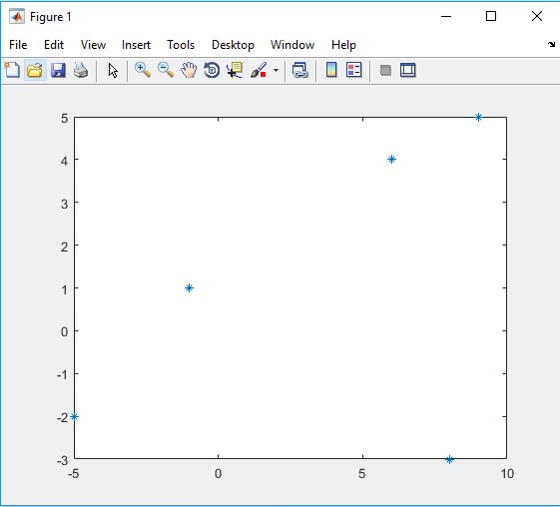

### Figure 3

Let’s plot y = x3 equation. We define 50 points for x. Then obtain the y from y = x3 equation (Figure 4).

x = 1:50; y = x.^3;

plot(x,y,'.')

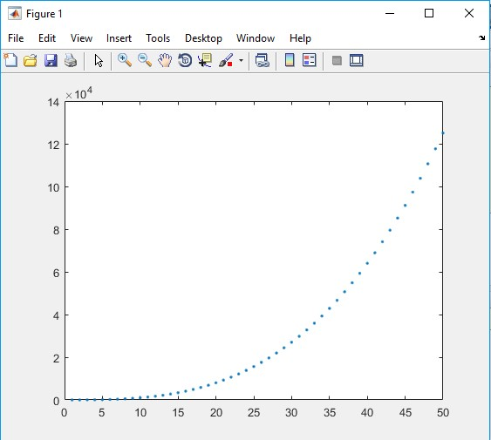

### Figure 4

We can connect the points by passing different parameter.

plot(x,y,'.-')

A hyphen after the dot means to connect the dots with a continuous line. You can also change the colors of the markers (Figure 5).

plot(x,y,'.-r') % r stands for red.

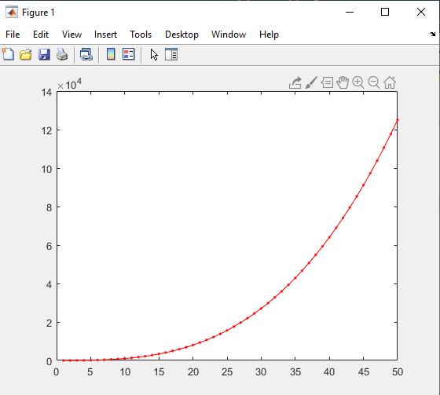

### Figure 5

Also, you can have multiple figures for multiple plotting. Say, we want the previous two equations to be plotted in two different figure windows. In that case, enter figure command to open a new figure (Figure 6).

x = 1:50; y = x.^3;

% new window

figure; plot(x,y,'.-b'); y = (x+10).^3;

% another new window

figure; plot(x,y,'.-r');



Figure 6

More about MATLAB plotting is available here [5].

**Practice Tasks:**

1. Square every element of the matrix A using one single line of command.
2. Square each elements of both A and B. Add the squared elements of A with the squared elements B and store them in the matrix C.
3. Multiply Two Matrices Using Multi-dimensional Arrays.

**References:**

1. <https://www.mathworks.com/help/matlab/learn_matlab/desktop.html>
2. <https://www.mathworks.com/help/matlab/elementary-math.html>
3. <https://www.mathworks.com/help/matlab/learn_matlab/matrices-and-arrays.html>
4. <https://www.mathworks.com/help/matlab/functionlist.html?s_cid=doc_ftr>
5. <https://www.mathworks.com/help/matlab/2-and-3d-plots.html>
6. <https://aust.edu/lab_manuals/CSE/CSE4228-Lab%20Manual.pdf>